GasUp Project Plan

#### ThePitCrew:

#### Sage Drewke

#### Joshua Hernandez

#### Brana Kim

#### 

#### 

#### 

#### 2/15/2023

### Introduction:

#### Scope and purpose of document (BK):

This project plan defines the scope of the project and how the project is predicted to be completed. It describes the main goal and the major functions of the application, as well as containing a system context diagram to show the information being exchanged. The main goal is elaborated on further by explaining what problem it is trying to solve and how it will benefit the users. What the company hopes to achieve by creating the application is also mentioned. The document also contains the predicted schedule for the project, which is shown through a Gantt chart. It illustrates the major milestones that need to be reached in the development of the project and the general timeline/deadlines. How the project will be monitored and kept up to date, as well as the team members' individual responsibilities are all specified in this document.

#### System Scope:

##### Problem/Opportunity Description (BK) -

GasUp is designed to make it easier for people to locate gas stations. Almost everyone who drives uses gas, because of this they constantly need to refill at a gas station. It's something that most people do in their daily lives and is present anywhere in the country. Many people are still using google or other sites to find information on prices, but this tends to be unreliable and sometimes the information they are looking for isn’t available. Plus there are very few major applications on the market that are designed to provide information/locations of gas stations. GasUp would help make finding something most people need their whole life more efficient.

##### Anticipated Business/Personal Benefits (BK)-

By creating an app that is accessible to everyone and can be used by many, we are able to put our foot in the door as a company. The success of the app may allow us to work with bigger companies and earn revenue through collaboration. Ideally in the future we would be able to expand past just car and gas related apps and work towards simplifying other tasks.

##### System Capabilities (BK) -

* Locate gas stations - All gas stations in a certain radius will be displayed on a map to the user at a given location. The user can sort by price, type of fuel, company, reviews, and distance.
* Navigate to gas stations - If the user selects a station they can choose to navigate to it. The app will pull up GPS directions to the selected station.
* Plan a Trip - The user can input their planned destination and the app will tell the user the gas stations along the way. Then the user can select stations they would like to add to their route and a new route with the stations along it will be created.
* Gas prices - All the prices of the gas at each station will be shown and the user can compare the prices of each station to each other. The user can also edit/update the price of the stations to match the current price. The date and time the price was updated will be shown.
* User reviews and hours- Users can leave reviews and images of each station. Others can then see the rating and look through the reviews and like or dislike them. Users can also add pump and store hours (if there is a store).
* MPG tracker - The app will calculate MPG for a user's car and create a graph. The user can input their mileage and gallons of gas they added at each refill. They can do this for multiple cars. This data can be compared to other cars of the same make and model.
* Notifications - The app will notify users of different information such as: price drops, price updates, review likes and dislikes, new stations nearby, etc. Users will be able to customize what notifications they would like to receive.

System Context Diagram (BK) –

<https://github.com/branakim/team-1-project/tree/main/GasUP%20project%20plan>

SCDGasUP.jpg

Schedule (SD):

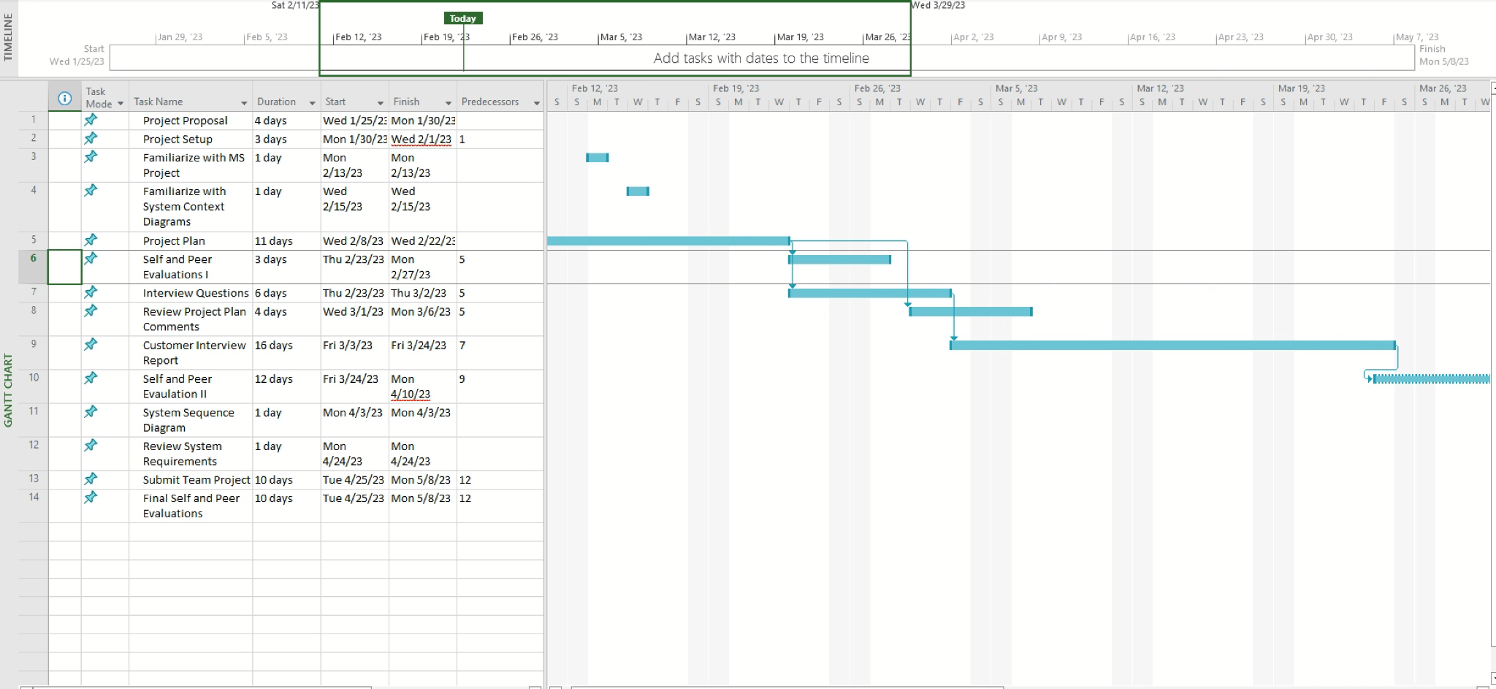

### Staff Organization:

#### Team Structure (BK):

### 

**Team Leader**

Joshua Hernandez

**Team Member**

Sage Drewke

**Team Member**

Brana Kim

### 

### Tracking and control mechanisms: (SD&BK)

GitHub -

All team members will share important files to the rest of the team in the Team 1-Project repository. GitHub will make it easier to keep the entire team up to date on current files, allowing members to make accurate adjustments.

Slack -

The team will use Slack to communicate via the Team 1 channel. This will be useful for collaborative tasks between select members of the team. During online team meetings, Slack will be the preferred method of communication for sending important links or attachments that cannot be put into the GitHub repository.

MS Project -

The Breakdown Structure Chart will be periodically updated and looked over by all team members. To make sure tasks are being completed on time, team members will consult the schedule at every team meeting.

Other Mechanisms -

To ensure all team members are effectively using their time, we will hold a team meeting online at least once or twice a week. At every team meeting, all members are responsible for reporting their individual progress. In addition, the team will consult the Breakdown Structure Chart to ensure tasks have been completed on time. Besides using Slack, members can also communicate via text. Documents are also shared through google drive.